Suspended Scaffold Hazard Awareness and Operator Safety Training

You must be able to apply the counterweight formula to complete this station

Rigging Checklist

What is the proposed load:___________________________________________

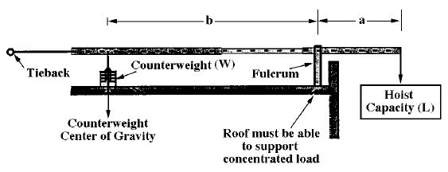

L = Load Capacity ________________________________
a = Arm Reach ___________________________________
b = Backspan Distance _____________________________
(Distance between the fulcrum point and the center of the counterweights)
4 = Safety Factor (4:1)

W = Counterweight_________________________
Number of Counterweights Required ______________________________

Student Initial for this Section ____________________

Check:
- Beam is properly sized for Outreach
- Counterweights are sized for outreach/backspace
  - Non flowable material
  - Positively attached
- Tieback anchor will hold load
- All terminations are correct
Student Initial for this Section ____________________

Equipment
Familiarize yourself with the following rigging equipment
- Cornice hook
- Parapet Clamp
- Rolling roof rig
- Tank Rollers
- Bull horn
- Beams (bolts, and attachements)
Student Initial for this Section ____________________

STUDENT SIGNATURE_______________________________

CHECK OFF DATE:___________________________________

